Introduction

This documents explains in details how to retrieve data from XSTUDIO , get it in EXCEL so that it can be used for different purpose – special presentation of the traceability matrix, new charting not already available in XSTUDIO …

Prequisite:
- you need to have access to MS Excel 2007 at the minimum,
- have read access to all the tables in XStudio
- Know the user/password for that access
- Be able to install an ODBC driver on your PC

Here we have used
- Windows 10
- Office 2013
- MySQL ODBC driver 64 bits, 5.3.1

A – install ODBC driver and enable a connection to be used by MS Excel

Open the ODBC Data Source manager (from Windows “start” button)
Check that the MySQL driver is available, clicking on the ‘drivers’ tab.
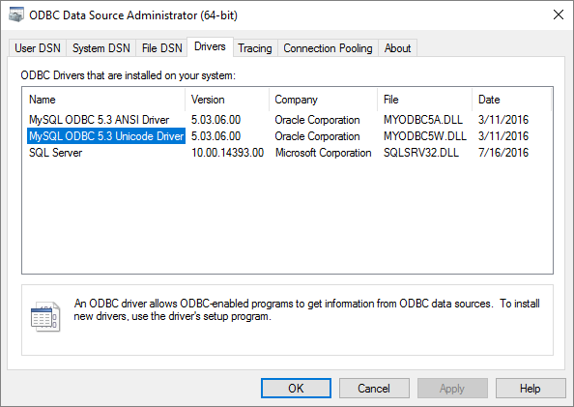

Then get into the ‘user DSN’ tab and ‘add’ a new connection.
Note: Here we choose to make the connection only available for the current user. If you wish to make this connection available to the PC and all users, you could then choose to create the connection in the system tab.

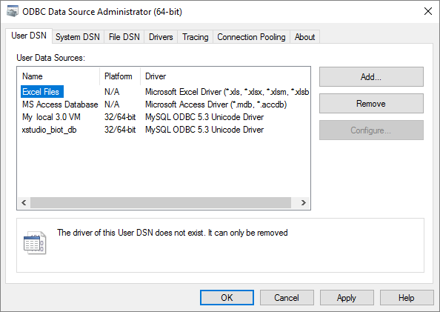

Choose the driver you want to use.
Note: If using accentuated characters (e.g. French language), you may need to choose the Unicode driver

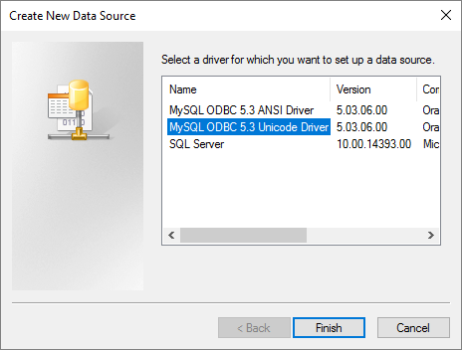

- Give a name to the connection (e.g. XSTUDIO),
- Provide the address of the MySQL server you want to connect to (here : 192.168.1.133) ,
- Indicate the port (default MYSQL port 3306 in this example),
- Provide the user and password you want to use (here we use the default admin account created with at installation time)

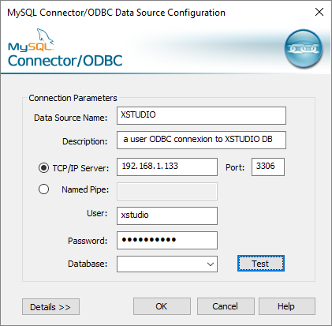

Click on ‘Test’ to ensure the connection is working.
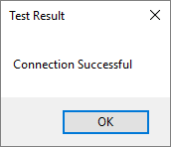
Then indicate you want to use the xstudio databse ( by default we use the ‘xstudio_db’, but you may have changed this)
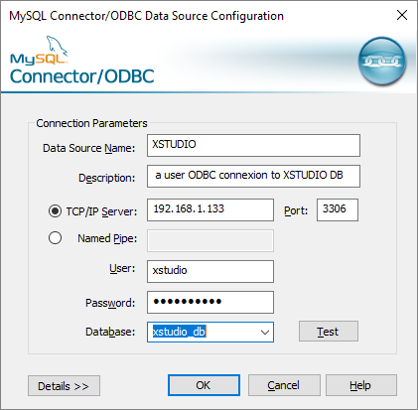

The connection is now created and usable for all Office applications.
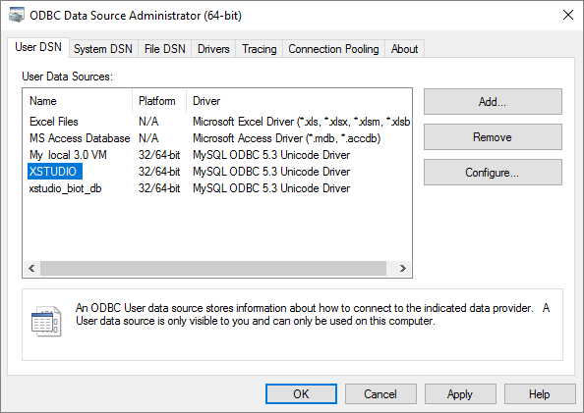

B- Use the connection from MS excel to create a simple query

Open MS Excel, and get to the ‘Data’ menu.
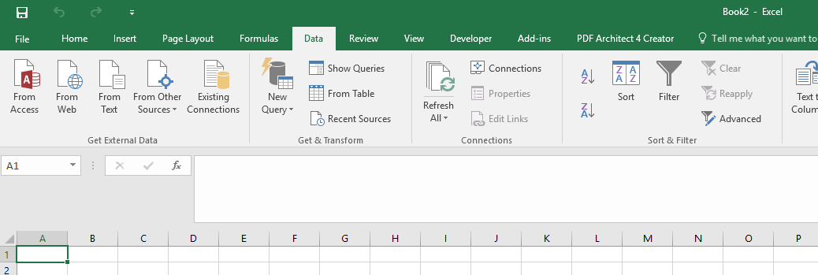

Then choose the menu ‘From Other Sources’, and sub menu ‘From Data Connection Wizard’

Note: there are other ways in Excel to create a query but here we stick with the most common present in office 2007, 2000 and later. If you feel comfortable using the Power Query tooling from Microsoft, do not hesitate. It provides more capabilities including the ability to manage a data model.

Then choose the ‘ODBC DSN’ option
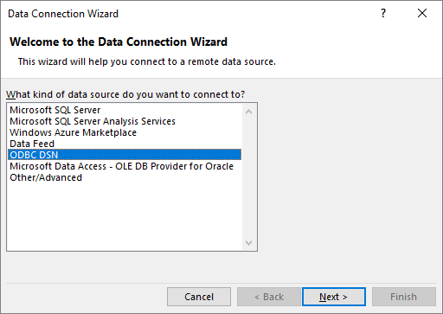

Choose the connection you just created (‘XSTUDIO’).
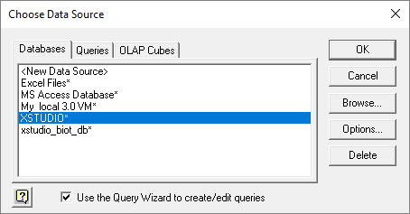

MS Query will then request you to choose the tables you want to work with.
In this example we just choose the SUT table; each table in XSTUDIO are prefixed with ‘Table_’ before the object name (e.g. table_SUT) and potential other postfix indicating what the table handles – e.g. table_sut_data handles the data for the SUT.

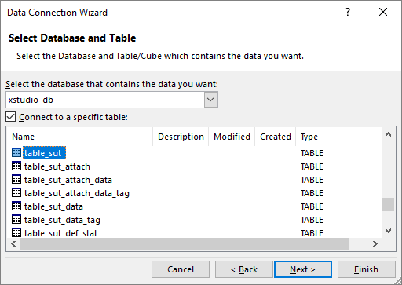

Do ‘next’ and then provide a name for you query and sufficient information to describe what this query is about.

Note: The ODBC Data Connection information is saved into an .odc file stored in C:\Users\<user>\Documents\My data source (under windows 10)

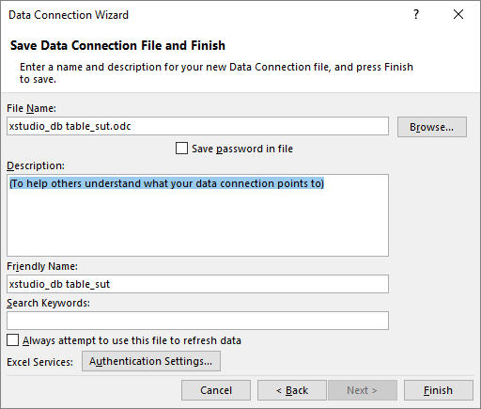

Click on ‘Finish’.
MS Excel proposes you to return data to a sheet either as a table or a pivot table or chart. For the time being we recommend you return it to a table as you can always create a pivot from that table later on.

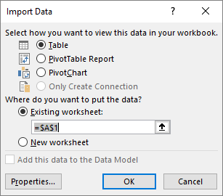

The data is then returned to that sheet. Here we just got the list of SUT (only 4 in this Database).
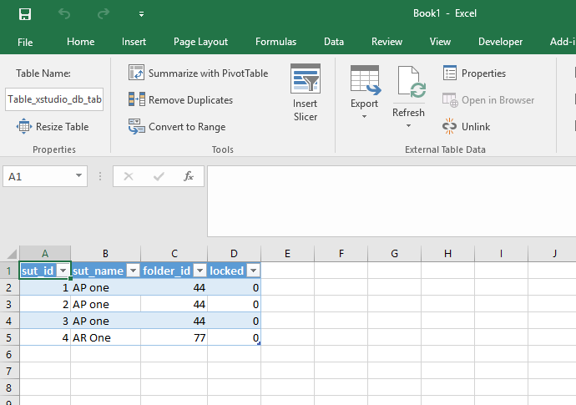

You can review and complete you query from there. Select one cell of the table, right-click and choose ‘Tables’, ‘Edit Query’
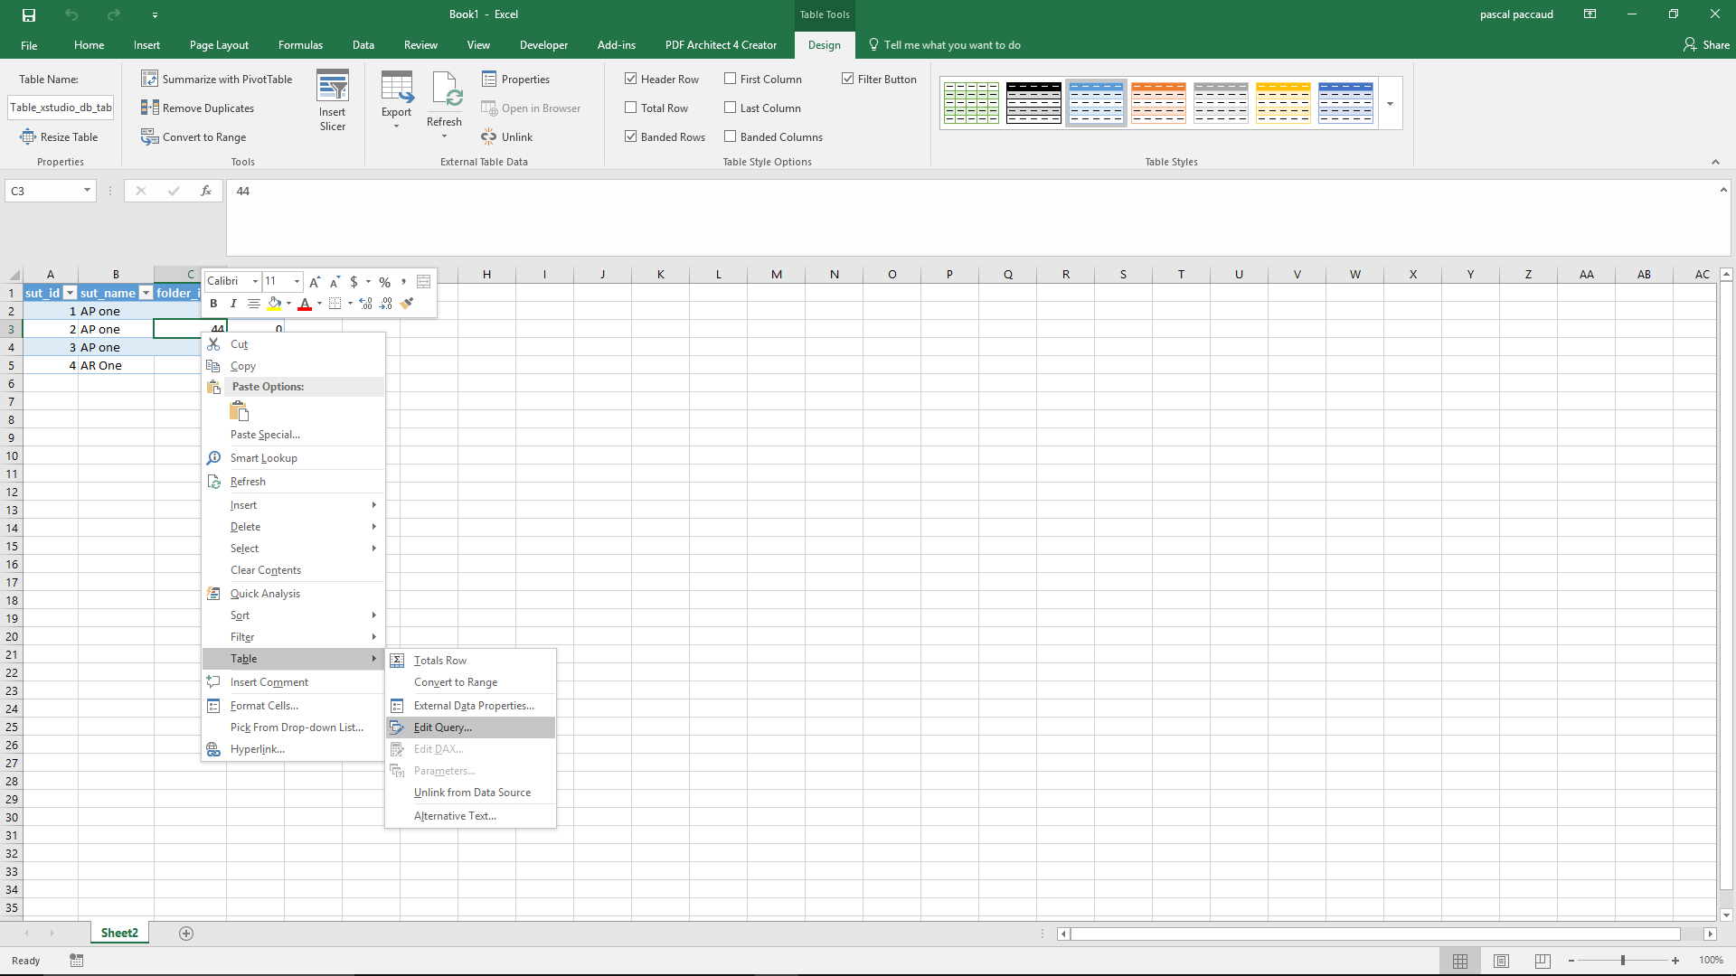

An error message may appear. Just click ‘OK’
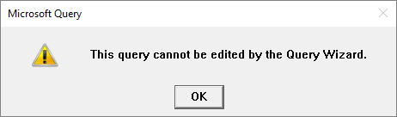

You then get a design window for your query. Here we just requested data from the ‘table_sut’ table.

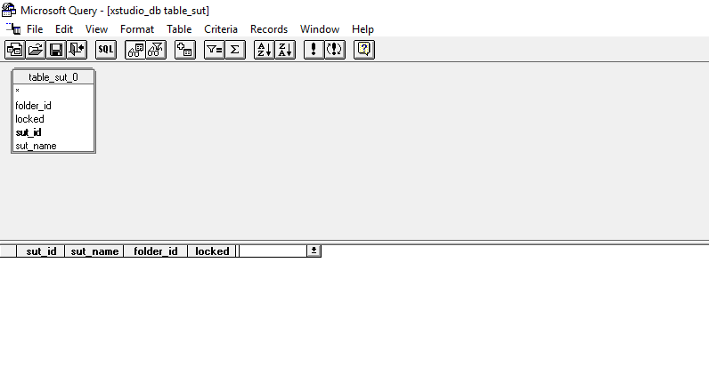

If you click on the ‘SQL’ menu you get the SQL query displayed.
Note: the table name are post fixed with ‘_0’. This is because you may need to use the same table in case of recursive links (e.g. The requirements can be linked to other requirements).
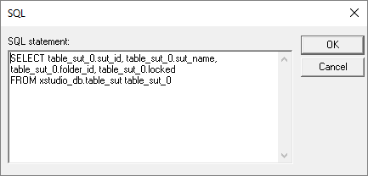

We will add some tables in our query in order to understand some basic notion of the XSTUDIO schema.

In the menu choose ‘Tables’, ‘add tables’

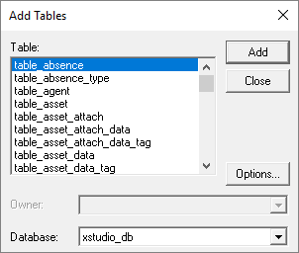

Scroll down and choose the table_sut_data and table_sut_data_tag
The first one contains the details about each SUT and the second one contains the tag for each entry.
Here is an important notion to know about the XSTUDIO schema.
Each time you change some data in an object (e.g. a SUT) and new record is entered into the ‘_data‘ table corresponding to that object. The latest entry is always having its tag = 10.

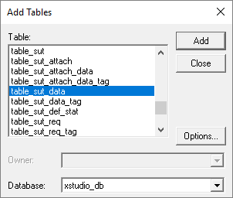

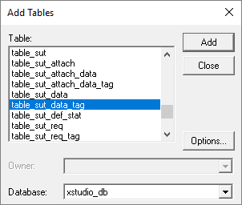

So once you have added the 2 tables, the query will show up as follows.
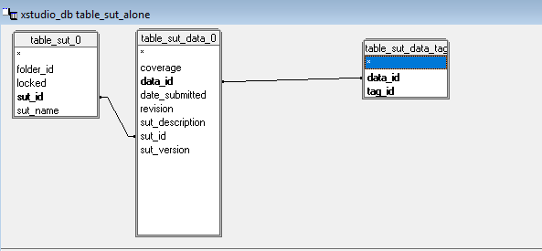
The sut_id is the primary key in the table_sut and is linked to the foreign key sut_id in the table_sut_data. And the data_id primary key is linked to the data_id in the table_sut_data_tag.
Warning: MS query automatically adds the joins between tables based on the field name; So be very careful when adding tables. If multiple tables use the same id, the link (join) will be created for you also they may be wrong – we will review this later down in this document.

The corresponding SQL request is presented by clicking on the SQL menu.

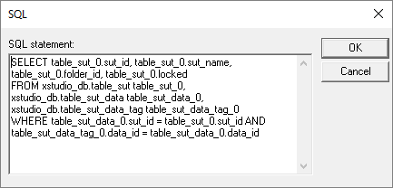

You can execute the query by clicking on the (!) button above. The data are then reported in the window below the schema design window.

Note: we recommend to turn off automatic query (in the ‘Records’ menu, uncheck the ‘Automatic Query’)
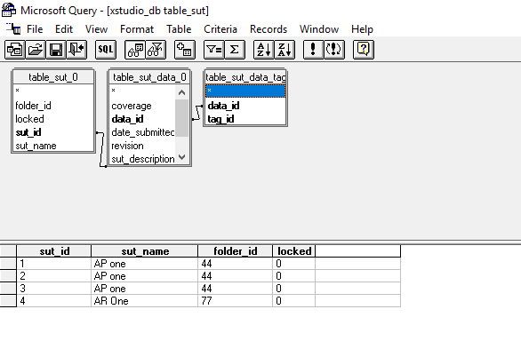

To ensure that only the last information for the data of the SUT appears we have to apply a criteria that ensure we only get the SUT with tag = 10.

For that,
- click on the ‘Criteria’ menu, in the ‘Field’,
- find the table_sut_data_tag_0.tag_id column,
- set ‘operator’ to ‘equals’ ,
- and choose the ‘Values’ and clik on ‘10’.
Then don’t forget to click on ‘Add’

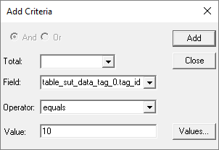

Finally, you need to add in your query the columns you want to retrieve.
For that
- just choose it from the design window
- and drag them on the header of the table below.
Don’t forget to re-execute the query (if you followed our recommendation to turn off automatic query)

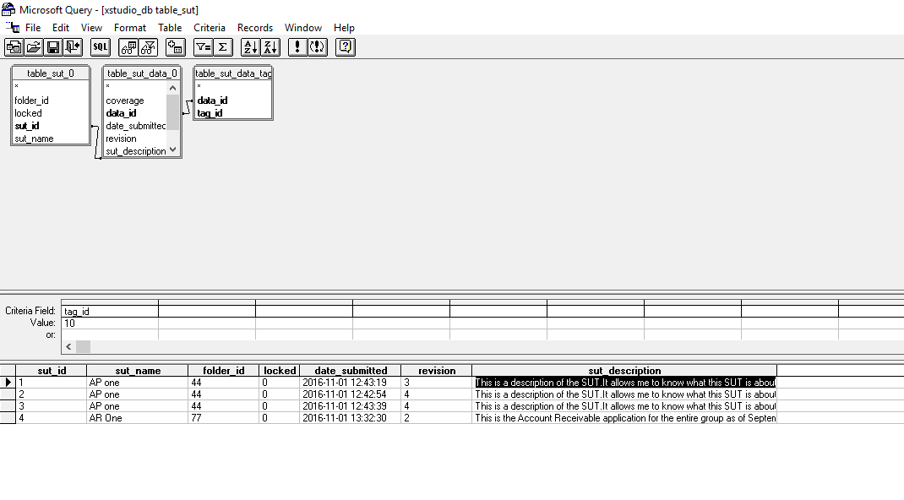
Again, click on the ‘SQL’ button will display the request as it is now.

SELECT table_sut_0.sut_id, table_sut_0.sut_name, table_sut_0.folder_id, table_sut_0.locked, table_sut_data_0.date_submitted, table_sut_data_0.revision, table_sut_data_0.sut_description
FROM xstudio_db.table_sut table_sut_0, xstudio_db.table_sut_data table_sut_data_0, xstudio_db.table_sut_data_tag table_sut_data_tag_0
WHERE table_sut_data_0.sut_id = table_sut_0.sut_id AND table_sut_data_tag_0.data_id = table_sut_data_0.data_id AND ((table_sut_data_tag_0.tag_id=10))

Note: you can copy/paste this query to the XSTUDIO report object and run it from there. It will allow you to see the same data. In the reverse way you can paste a report from XSTUDIO SQL report.

C- add more tables and join.
Then we add some other tables to see the requirement that are linked to the SUT.

In the same way we extracted the data for the SUT you can then add the information to extract the information from the Requirements.
To do that, add tables:
- Table_req_int
- Table_req_int_data
- Table_req_int_data_tag
Warning: be careful as you add tables with the same tag_id , data_if field name. So MS Query adds automatically the join. You just need to click on the one you don’t need and delete them.
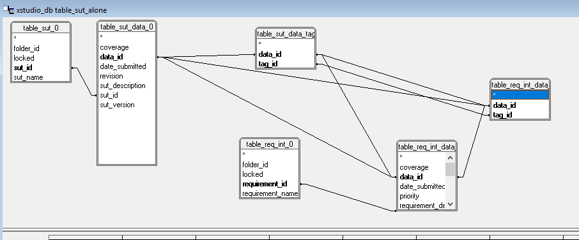
After removing the joins we don’t need we get the following design
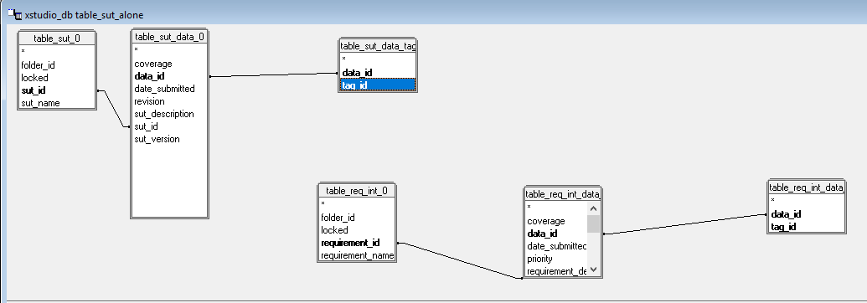

Now we need to link the SUT to the Requirements.
This information is stored in the table_sut_req table.

Add it to the design
Note that joins are correct here

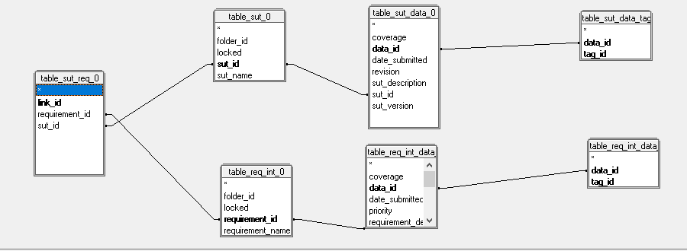

Last do not forget to add the table_sut_req_tag. Remember that the objects are all versioned and tagged. But so are the links !
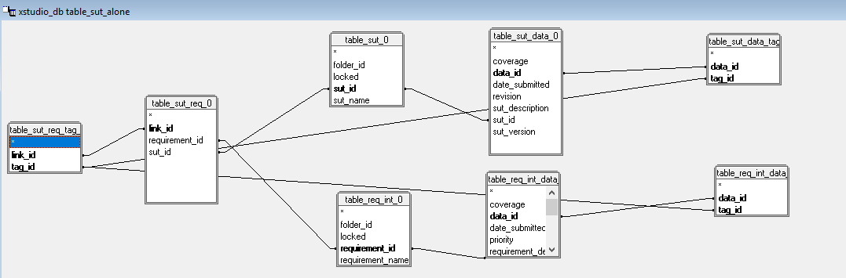

Again remove the fake joins automatically created by MS query

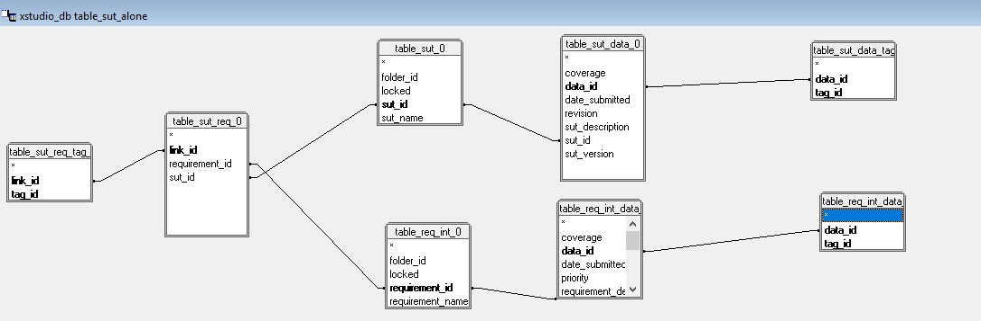

Add the following criteria allowing you to only get the latest version of the requirements and the latest version of the links between the SUT and requirements.
Add ‘criteria‘
- for table_sut_req_tag.tag_id’ equals to ‘10’
- for table_req_int_data_tag.tag_id is equals to ‘10’

And then add the columns you want to retrieve by dragging the field from the design window onto the header of the table window.

If you display the SQL request you should get the following:

SELECT table_sut_0.sut_id, table_sut_0.sut_name, table_sut_0.folder_id, table_req_int_0.requirement_id, table_req_int_0.requirement_name, table_req_int_data_0.date_submitted, table_req_int_data_0.priority
FROM xstudio_db.table_req_int table_req_int_0, xstudio_db.table_req_int_data table_req_int_data_0, xstudio_db.table_req_int_data_tag table_req_int_data_tag_0, xstudio_db.table_sut table_sut_0, xstudio_db.table_sut_data table_sut_data_0, xstudio_db.table_sut_data_tag table_sut_data_tag_0, xstudio_db.table_sut_req table_sut_req_0, xstudio_db.table_sut_req_tag table_sut_req_tag_0
WHERE table_sut_data_0.sut_id = table_sut_0.sut_id AND table_sut_data_tag_0.data_id = table_sut_data_0.data_id AND table_req_int_data_0.requirement_id = table_req_int_0.requirement_id AND table_req_int_data_tag_0.data_id = table_req_int_data_0.data_id AND table_sut_req_0.requirement_id = table_req_int_0.requirement_id AND table_sut_req_0.sut_id = table_sut_0.sut_id AND table_sut_req_tag_0.link_id = table_sut_req_0.link_id AND ((table_sut_data_tag_0.tag_id=10) AND (table_req_int_data_tag_0.tag_id=10) AND (table_sut_req_tag_0.tag_id=10))

Finally, you save your query with the name you want – this query can then be used in any excel (provided the PC on which you execute it has the connectors and drivers.
- Do menu ‘File’, ‘save as…’ and save with the name you need.
Note: the folder is in <users>\<user>\AppData\Roaming\Microsoft\Queries and the extension of the file is .dqy

You are done with creating your query.
You can return the query and the retrieved data to you Excel by doing ‘File’, ‘Retun Data to Microsoft Excel’.

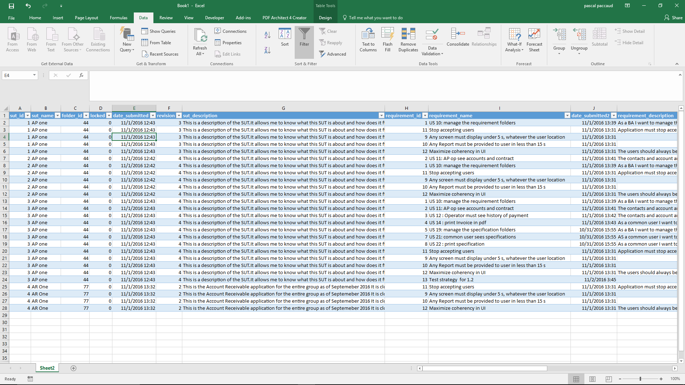

- Each time you open your Excel workbook the data are refreshed.
- You can also force “Refresh” by selecting one cell in the table and then right clicking , you choose ‘refesh’.

D-Use the data for you specific need
From there you can create any report you need.

For example in the following we just created a pivot that list the SUT_id n the sut_name, sut_version the req_id and the req_name , and presented it as a Tabular_report without Totals
